TAKE NOTICE that the Board of Directors of the Harris County - Houston Sports Authority (the "Authority") will meet, open to the public, in the HFC Board/Training Room on the second floor of Partnership Tower, 701 Avenida de las Americas, Houston, Texas 77010, at 10:00 a.m. on Thursday, August 4, 2022.* At such meeting the Board will consider the following matters:

- Call to order and introduction of guests in attendance. Friedman
- Public Comments.

- Presentation and approval of the Minutes from the Board Meeting held on June 9, 2022. Friedman

- Chairman's Report Friedman
- Final reminder that a copy of each Director's PFS is required to be provided to the
Authority for its files;
- TIRR Memorial – check presentation;
- 25-year Anniversary – September 1, 2022.

- Financial Report. Callier
- Discussion and review of Quarterly Investment Report and Quarterly Portfolio Compliance
Report for 2022 Quarter 2;
- Discussion and review of unaudited 2022 year-to-date financials;
- Discussion and possible action regarding renewing audit firm contract.

- Chief Executive Officer's Report Burke
- Update on activities and sporting events.

EXECUTIVE SESSION: Pursuant to provisions of Chapter 551, Texas Government Code, the Board shall deliberate in Executive Session on the following: consultation with attorneys on legal matters, pursuant to Section 551.071; deliberation on real estate matters, pursuant to Section 551.072; and deliberation on personnel matters, pursuant to Section 551.074.

Reconvene in Public Session and announce any items from Executive Session; discussion and possible action on such items.

- Discussion and possible action regarding the Sports Authority Foundation. Friedman

- Comments by Directors, if any.

- Adjournment.

Dated: July 29, 2022

Harris County - Houston Sports Authority
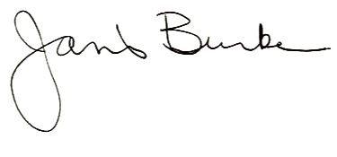

*YOU MAY CONFIRM THAT A MEETING WILL BE HELD (AND HAS NOT BEEN CANCELLED) BY CALLING THE AUTHORITY'S OFFICE AT 713-308-5900, OR BY CHECKING THE AUTHORITY'S WEBSITE
www.HoustonSports.org

