SPORTS AUTHORITY FOUNDATION

AGENDA

TAKE NOTICE that the Board of Directors of the Sports Authority Foundation (the “Foundation”) will meet, open to the public, in the offices of the Harris County – Houston Sports Authority (“HCHSA”), on the fourth floor of Partnership Tower, located at 701 Avenida de las Americas, Houston, Texas 77010, at 11:30 a.m., on Friday, December 9, 2022.* At such meeting the Board will consider the following matters:
1. Call to order and introduction of guests in attendance. Callier

2. Update regarding Foundation-related sales, marketing, and sponsorship initiatives. Burke
a. Presentation of completed event budgets;
b. Presentation of new event budgets for acceptance; and
c. Update on future initiatives

3. EXECUTIVE SESSION: Pursuant to provisions of Chapter 551, Texas Government Callier
Code, the Board shall deliberate in Executive Session on the following: consultation with
attorneys on legal matters, pursuant to Section 551.071; deliberation on real estate matters,
pursuant to Section 551.072; and deliberation on personnel matters, pursuant to Section 551.074.

4. Reconvene in Public Session and announce any items from Executive Session Callier
requiring Board action.

5. Discussion and possible vote on the structure of the Sports Authority Foundation. Burke

6. Comments by Directors, if any.

7. Adjournment.

Dated: December 2, 2022
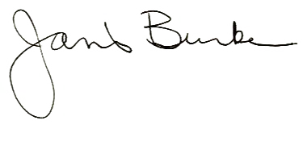

___________________________________
Harris County – Houston Sports Authority

