HARRIS COUNTY-HOUSTON SPORTS AUTHORITY
N O T I C E
TAKE NOTICE that the Finance Committee of the Harris County-Houston Sports Authority (the “Authority”) will hold a meeting* open to the public, in the Large Conference Room of the Authority’s offices located on the Fourth Floor of the Partnership Tower, 701 Avenida de las Americas, Houston, Texas, 77010, on December 8, 2022, at 9:00 a.m. CDST, to consider the following matters:

1. Call to order.

2. Discussion of the 2023 General & Administrative Budget.

3. EXECUTIVE SESSION: Pursuant to provisions of Chapter 551, Texas Government Code,
the Committee shall deliberate in Executive Session on the following: consultation with
attorneys on legal matters; deliberation on real estate matters; and deliberation on
personnel matters.

4. Reconvene in Public Session and announce any items from Executive Session; discussion
and possible action on such items.

5. Approval of the 2023 General & Administrative Budget.

6. Adjournment

* NO FINAL ACTION will be taken at this meeting. The Finance Committee will only discuss possible recommendations. All recommendations discussed above MUST BE FURTHER DISCUSSED AND CONSIDERED by the full Board of Directors of the Harris County - Houston Sports Authority.

Dated: December 2, 2022

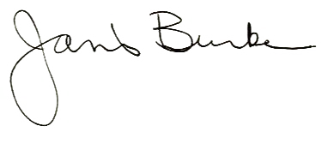

_______________________________
Harris County – Houston Sports Authority

